Chapter 10 – 11 Short Answer Problems

Intermolecular Forces and Physical Properties
- Compare and contrast typical dipole-dipole forces with hydrogen bonding interactions.
- Describe the relationship between molecular size and strength of London dispersion forces.
- How do the following physical properties depend on the strength of intermolecular forces?
  - Surface tension: ___________________________________________________________________
  - Viscosity: ___________________________________________________________________
  - Melting point: ___________________________________________________________________
  - Boiling point: ___________________________________________________________________
  - Vapor pressure: ___________________________________________________________________
- Identify the most important types of interparticle forces (LD, Dipole, H-bonding, Ionic) present in the solids of each of the following substances.

  - Ar
  - HCl
  - HF
  - CaCl₂
  - CH₄CO
  - NaNO₃
  - NH₃
  - CHCl₃
  - BF₃

- Predict which substances in each of the following pairs would have the greater intermolecular forces.
  - CO₂ or OCS
  - PF₃ or PF₅
  - SO₃ or SO₂
- In each of the following groups of substances, pick the one that has the given property. Justify your answer.
  - Highest boiling point: HCl, Ar, or F₂ _______________________
  - Highest freezing point: H₂O, NaCl, or HF _______________________
  - Lowest vapor pressure at 25ºC: Cl₂, Br₂, I₂ _______________________
  - Lowest freezing point: N₂, CO, or CO₂ _______________________
  - Lowest boiling point: CH₄, CH₃CH₃, or CH₃CH₂CH₃ _______________________
  - Highest boiling point: HF, HCl, or HBr _______________________

Liquids & Vapor Pressure
- In what ways are liquids similar to solids?

- In what ways are liquids similar to gases?
- How does each of the following affect the rate of evaporation of a liquid in an open dish?
  - Intermolecular forces: ______________________________________________
  - Temperature: ______________________________________________
  - Surface area: ______________________________________________
- What do we mean that we say that a liquid is volatile? _______________________________________
Do volatile liquids have large or small vapor pressures at room temperature? ____________
What strengths of intermolecular forces occur in highly volatile liquids?__________________
- Hydrogen peroxide (H₂O₂) is a syrupy liquid with a relatively low vapor pressure and a normal boiling point of 152.2ºC. Explain the differences of these physical properties from those of water.

- The solubility of sodium chloride in water at 25ºC is 12.0 g in 100 mL of solution. How many grams of sodium ion will be found in one liter of solution?

- Consider the following vapor pressure vs. temperature plot for three different substances A, B, C. If the three substances are CH₄, SiH₄, and NH₃, match each curve to the correct substance. Explain your choices.
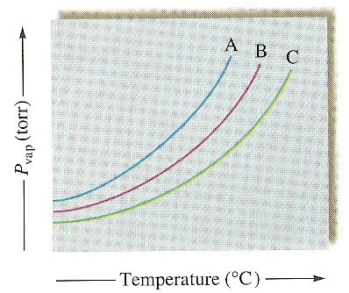

Structures and Properties of Solids
- What type of solid will each of the following substances form?
[ionic, molecular, atomic (metallic or covalent network?)]

  - CO₂
  - Si
  - CH₄
  - Ru
  - I₂
  - KBr
  - H₂O
  - NaOH
  - U
  - CaCO₃
  - PH₃
  - Diamond
  - Cu

Phase Changes and Heating Curves
- As you are heating up a substance, why doesn’t the temperature increase continuously over time? That is, why does the temperature stay constant for periods of time?
- Why is the enthalpy of vaporization for water much greater than its enthalpy of fusion? What does this say about changes in intermolecular forces in going from a solid to liquid to vapor?
- A substance, X, has the properties below. Sketch a heating curve for substance X starting at -50.ºC.
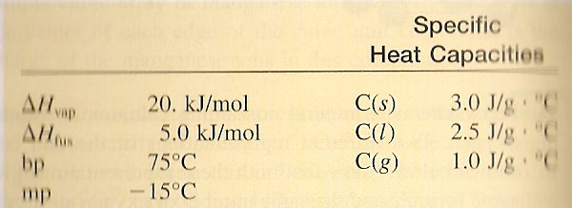
Molarity
1. What is the molarity of a solution in which 58g of NaCl are dissolved in 1.0L of solution?
2. What is the molarity of a solution in which 10.0g of AgNO3 is dissolved in 500mL of solution?
3. How many grams of KNO3 should be used to prepare 2.00L of a 0.500 M solution?
4. To what volume should 5.0 g of KCl be diluted in order to prepare a 0.25 M solution?
5. How many grams of CuSO₄ are needed to prepare 100.0 mL of a 0.10 M solution?

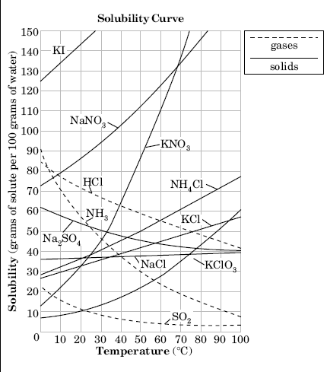
Solubility Curves

1. Which SALT is least soluble in water at 20ºC?
2. How many grams of KCl can be dissolved in 200g of water at 80ºC?

3. At 40ºC, how much KNO₃ can be dissolved in 300g of water?

4. At 30ºC, 90g of NaNO₃ is dissolved in 100g of water. Is this solution saturated, unsaturated or super saturated?
5. Which salt is most soluble at 10ºC?
6. If a saturated solution of NH₄Cl (at 70ºC) is cooled until it is at 50ºC. How much would precipitate out of the solution?
7. Which substance shows the least change in solubility from 0ºC to 100ºC?

