AP Chemistry Concept List – ACID - BASE

pH = - log [H⁺] pOH = - log [OH⁻] K_{w} = [H⁺] [OH⁻] = 1×10⁻¹⁴ at 25 ºC

If you know one quantity, you know the other three

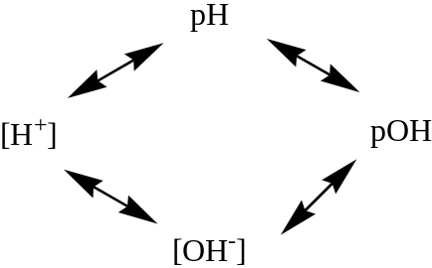

Definitions

Acid | Base | Theory
Donates H⁺ | Donates OH⁻ | Arrhenius
Donates protons | Accepts protons - {anions?} | Bronsted – Lowry
Accepts e⁻ pairs (AlCl₃) | Donates e⁻ pairs (NH₃) | Lewis

Conjugate Acid – Base Pairs

1. HCl + H₂O → H₃O⁺ + Cl⁻

2. NH₃ + H₂O → NH₄⁺ + OH⁻

3. HSO₄⁻ + H₂O → H₃O⁺ + SO₄²⁻

4. CO₃²⁻ + H₃O⁺ → HCO₃⁻ + H₂O

A. K_{a} Weak Acid HCN → H⁺ + CN⁻

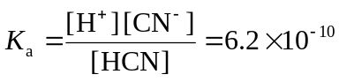

What is the pH of a 0.5 M HCN solution?

B. K_{b} Weak base NH₃ + H₂O → NH₄⁺ + OH⁻

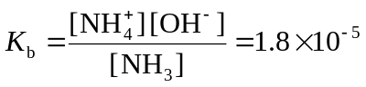

What is the pH of a 0.5 M NH₂OH solution?

C. K_{sp} Insoluble Salts MgF₂(s) →Mg²⁺ + 2F⁻

K_{sp} = [Mg²⁺] [F⁻]² = 6.6 × 10⁻⁹

What is the solubility of MgF₂ in molarity?

D. Buffers – a weak acid/base and its soluble salt (conjugate base or acid) mixture

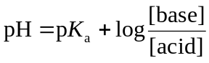

What is the pH of a 0.5 M HC₂H₃O₂ in 2 M NaC₂H₃O₂ solution? K_{a} = 1.8 × 10⁻⁵

E. Salts of Weak Acids and Weak Bases

What is the pH of a 1 M NaC₂H₃O₂ solution?

Titrations and Endpoints

At endpoint: acid moles = base moles or [H⁺] = [OH⁻]

Strong acid – strong base endpoint pH = 7

Strong acid – weak base endpoint pH < 7

Weak acid – strong base endpoint pH > 7

The last two are important because of conjugate acid and base pairs
2007 #1

1. HF(aq) + H₂O(l)  H₃O⁺(aq) + F⁻(aq) K_{a} = 7.2 × 10⁻⁴

Hydrofluoric acid, HF(aq), dissociates in water as represented by the equation above.

a. Write the equilibrium constant expression for the dissociation of HF(aq) in water.

b. Calculate the molar concentration of H₃O⁺ in a 0.40 M HF(aq) solution.

HF(aq) reacts with NaOH(aq) according to the reaction represented below.

HF(aq) + OH⁻(aq)  H₂O(l) + F⁻(aq)

A volume of 15 mL of 0.40 M NaOH(aq) is added to 25 mL of 0.40 M HF(aq) solution. Assume volumes are additive.

c. Calculate the number of moles of HF(aq) remaining in the solution.

d. Calculate the molar concentration of F⁻(aq) in the solution.

e. Calculate the pH of the solution.

2005B #1 K_{a}

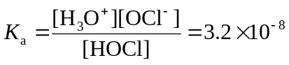

1. Hypochlorous acid, HOCl, is a weak acid in water. The K_{a} expression for HOCl is shown above.

a. Write a chemical equation showing how HOCl behaves as an acid in water.

b. Calculate the pH of a 0.175 M solution of HOCl.

c. Write the net ionic equation for the reaction between the weak acid HOCl(aq) and the strong base NaOH(aq)

d. In an experiment, 20.00 mL of 0.175 M HOCl(aq) is placed in a flask and titrated with 6.55 mL of 0.435 M NaOH(aq).

i) Calculate the number of moles of NaOH(aq) added.

ii) Calculate [H₃O⁺] in the flask after the NaOH(aq) has been added.

iii) Calculate [OH⁻] in the flask after the NaOH(aq) has been added.

1999 #1 K_{b}

NH₃(aq) + H₂O(l)  NH₄⁺(aq) + OH⁻(aq)

In aqueous solution, ammonia reacts as represented above. In 0.0180 M NH₃(aq) at 25°C, the hydroxide ion concentration, [OH⁻] , is 5.60 × 10⁻⁴ M. In answering the following, assume that temperature is constant at 25°C and that volumes are additive.

a. Write the equilibrium-constant expression for the reaction represented above.

b. Determine the pH of 0.0180 M NH₃(aq).

c. Determine the value of the base ionization constant, K_{b}, for NH₃(aq).

d. Determine the percent ionization of NH₃ in 0.0180 M NH₃(aq).

e. In an experiment, a 20.0 mL sample of 0.0180 M NH₃(aq) was placed in a flask and titrated to the equivalence point and beyond using 0.0120 M HCl(aq).

i. Determine the volume of 0.0120 M HCl(aq) that was added to reach the equivalence point.

ii. Determine the pH of the solution in the flask after a total of 15.0 mL of 0.0120 M HCl(aq) was added.

iii. Determine the pH of the solution in the flask after a total of 40.0 mL of 0.0120 M HCl(aq) was added.

1996 A/B lab #6

A 0.500-gram sample of a weak, nonvolatile acid, HA, was dissolved in sufficient water to make 50.0 milliliters of solution. The solution was then titrated with a standard NaOH solution. Predict how the calculated molar mass of HA would be affected (too high, too low, or not affected) by the following laboratory procedures. Explain each of your answers.

a. After rinsing the buret with distilled water, the buret is filled with the standard NaOH solution; the weak acid HA is titrated to its equivalence point.

b. Extra water is added to the 0.500-gram sample of HA.

c. An indicator that changes color at pH 5 is used to signal the equivalence point.

2000 #8 A/B Lab

A volume of 30.0 mL of 0.10 M NH₃(aq) is titrated with 0.20 M HCl(aq). The value of the base-dissociation constant, K_{b}, for NH₃ in water is 1.8 × 10⁻⁵ at 25 ºC.

a. Write the net-ionic equation for the reaction of NH₃(aq) with HCl(aq).

b. Using the axes provided below, sketch the titration curve that results when a total of 40.0 mL of 0.20 M HCl(aq) is added dropwise to the 30.0 mL volume of 0.10 M NH₃(aq).

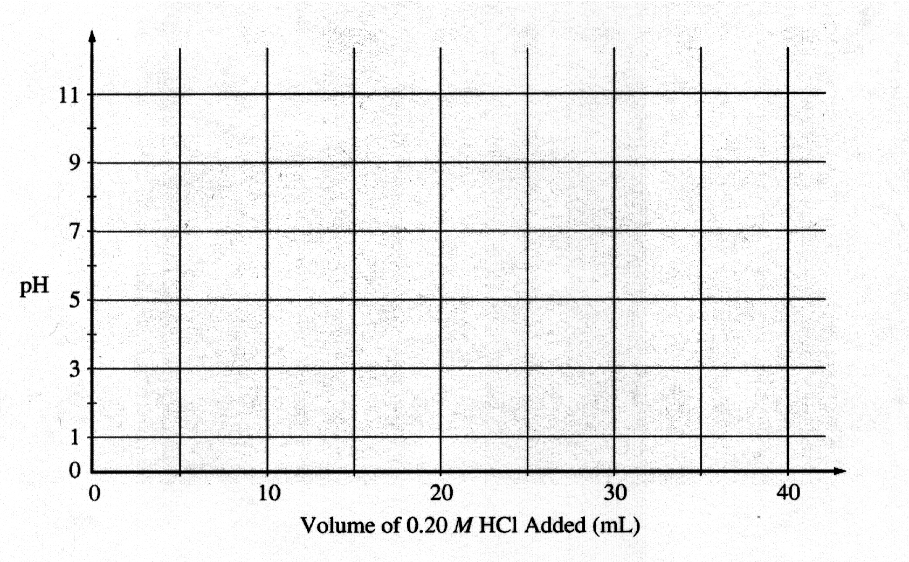
c. From the table below, select the most appropriate indicator for the titration. Justify your choice

Indicator | pK_{a}
Methyl Red | 5.5
Bromothymol Blue | 7.1
Phenolphthalein | 8.7

d. If equal volumes of 0.10 M NH₃(aq) and 0.10 M NH₄Cl(aq) are mixed, is the resulting solution acidic, neutral, or basic? Explain

K_{sp} 1998 #1

Solve the following problem related to the solubility equilibria of some metal hydroxides in aqueous solution.

a. The solubility of Cu(OH)₂ is 1.72 × 10⁻⁶ gram per 100. mL of solution at 25 °C.
(i) Write the balanced chemical equation for the dissociation of Cu(OH)₂(s) in aqueous solution.
(ii) Calculate the solubility (in moles per liter) of Cu(OH)₂ at 25 °C.
(iii) Calculate the value of the solubility-product constant, K_{sp}, for Cu(OH)₂ at 25 °C.

b. The value of the solubility-product constant, K_{sp}, for Zn(OH)₂ is 7.7 × 10⁻¹⁷ at 25°C.
(i) Calculate the solubility (in moles per liter) of Zn(OH)₂ at 25°C in a solution with a pH of 9.35.
(ii) At 25°C, 50.0 mL of 0.100-molar Zn(NO₃)₂ is mixed with 50.0 mL of 0.300-molar NaOH. Calculate the molar concentration of Zn²⁺(aq) in the resulting solution once equilibrium has been established. Assume that volumes are additive.

2001 K_{sp}

Answer the following questions relating to the solubility of the chlorides of silver and lead.

a. At 10 ºC, 8.9 × 10⁻⁵ g of AgCl(s) will dissolve in 100. mL of water.

i. Write the equation for the dissociation of AgCl(s) in water.

ii. Calculate the solubility, in mol L⁻¹, of AgCl(s) in water at 10 ºC.

iii. Calculate the value of the solubility-product constant, K_{sp}, for AgCl(s) at 10 ºC.

b. At 25 ºC, the value of K_{sp} for PbCl₂(s) is 1.6 × 10⁻⁵ and the value of K_{sp} for AgCl(s) is 1.8 × 10⁻¹⁰.

i. If 60.0 mL of 0.0400 M NaCl(aq) is added to 60.0 mL of 0.0300 M Pb(NO₃)₂(aq), will a precipitate form? Assume that volumes are additive. Show calculations to support your answer.

ii. Calculate the equilibrium value of [Pb²⁺(aq)] in 1.00 L of saturated PbCl₂ solution to which 0.250 mole of NaCl(s) has been added. Assume that no volume change occurs.

iii. If 0.100 M NaCl(aq) is added slowly to a beaker containing both 0.120 M AgNO₃(aq) and 0.150 M Pb(NO₃)₂(aq) at 25 ºC, which will precipitate first, AgCl(s) or PbCl₂(s)? Show calculations to support your answer.

